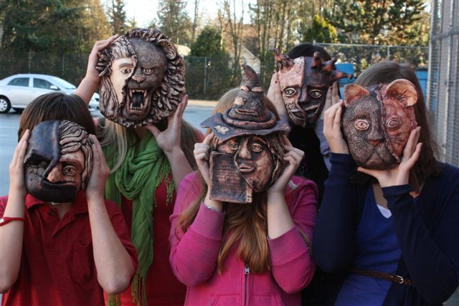
Are you a student who:
Is JumpstArt 9 at Gleneagle right for you?
JumpstArt 9 is a thematically integrated, enriched Art/Humanities program offered only at Gleneagle Secondary. Students in JumpstArt earn credit for English, Social Studies and two Visual Arts courses simultaneously while working together for half of each day through the entire year.

• is always drawing, doodling and thinking visually?
• wants to find connections between English, Social Studies
and Visual Arts?
• is interested in big ideas like freedom, identity, and
independence?
• is looking to express your learning in a variety of ways?
• contributes to group projects and discussions?

JumpstArt: thinking inside, outside and around the box.

Email Mr. Mike McElgunn at mmcelgunn@sd43.bc.ca or visit http://bit.ly/YaRNuw for more information.

